

Feature: The Orchestrotica
March 22, 2013

Is there someone who doesn´t know Esquivel?

“Mini Skirt” is pianist and percussionist Brian O’Neill’s favorite piece with which to kick off a party. And without a doubt, it’s also one of the favorites of the followers of Juan García Esquivel (1918-2002), the great genius of space age pop, whose followers almost filled the Teatro de la Ciudad to listen to the Orchestrotica, a Big band led by Mr. Ho, who is none other than O’Neill himself.
WHAT WAS SAID:

“I knew a little bit about him thanks to my boyfriend and my parents. I liked the way he performed everything and how he gets into the music. Seeing him makes you feel you’re in a very special place”.

Aída Lazcano
Industrial Designer

O’Neill has dedicated himself to transcribing Esquivel’s long-lost arrangements and compositions from his recordings, with the goal being to perform them live with a large orchestra.

At Wednesday’s concert Mr. Ho invited a number of musicians from Victor Guzmán’s orchestra to join the Orchestrotica (Guzman himself having played with Esquivel and someone who had only praise for his American colleague).

“Is there anyone out there who doesn’t know who Juan García Esquivel is?” the percussionist asked the audience. Only a few hands went up in the theater. “Don’t be shy”, insisted O’Neill, who offered to explain–in Spanish–a few things about the Orchestrotica’s music.

Mr. Ho multiplies on stage. He takes the microphone, perhaps to discuss the enormous difficulty of the trumpet and flute parts, or to reveal some of Esquivel’s peculiar instrumentation, or to play a tambourine solo (he sees himself more a percussionist than a pianist) and he even directs the orchestra while dancing.

During the concert, several well-known pieces could be heard like Night and Day, So Rare, Frenesí, Dancing in the Dark, Mucha Muchacha and Torna a Sorrento.

Mr. Ho ended the performance with the first Esquivel arrangement he had ever heard by Esquivel, The Breeze and I (Andalucía), which is also included on the first of two albums from his own band’s “Exotica for Modern Living” series.

“It was excellent, an update about the future; music of the 50s and 60s that takes us to the 21st century. It’s a shame that it took an American to do this; a Mexican should have. It’s a road from Esquivel to Frank Zappa, there and back, this is why it’s the future of the past” said historian Ernesto Jiménez.

In the audience there was everything from young people that had recently discovered Esquivel’s sound to the ones that grew up listening to his music, including Ignacio Toscano who is the director of Instrumenta Oaxaca.

“The musicians they brought were top notch. The sound was perfect, but the most important thing was rescuing Juan García Esquivel’s music. I have to confess something: I know a lot of them [the songs]. Odisea Burbujas is not my thing, but what Esquivel did with Mexico’s great musicians (…) is part of the musical history of this country,” said Toscano.

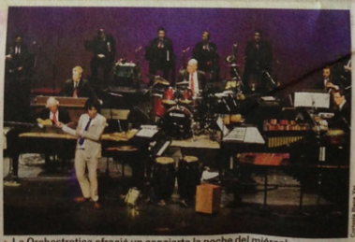

Photo caption:

The Orchestrotica offered a concert the night of Wednesday at the Teatro de la Ciudad, with music by Juan García Esquivel.

Translated by Arturo Jimenez.

